API Resource

🌐 What is an API Resource
# Source: AI Source: Provided by: [Data Path: Persons Table -> ID Column: 1, Name_En Column: Motasem Essam] -> From: [ChatGPT] on [1/19/2026]
In the context of web APIs, a Resource is any entity or object that can be accessed, manipulated, or represented via the API.
👉 Think of a Resource as “something the API exposes”, usually representing data in your system.

🔑 Key Points About API Resources
# Source: AI Source: Provided by: [Data Path: Persons Table -> ID Column: 1, Name_En Column: Motasem Essam] -> From: [ChatGPT] on [1/19/2026]
- Represents real-world or domain entities
  - Example: User, Product, Order, Invoice
- Accessible via a unique URL (endpoint)
  - Example: /users/123 → represents a specific user
- Supports standard operations (CRUD)
  - Create → POST
  - Read → GET
  - Update → PUT/PATCH
  - Delete → DELETE
- Returns a representation of data
  - Usually JSON, XML, or other formats

🧱 Example: User Resource
# Source: AI Source: Provided by: [Data Path: Persons Table -> ID Column: 1, Name_En Column: Motasem Essam] -> From: [ChatGPT] on [1/19/2026]
Endpoint
GET /users/123
Response (JSON)
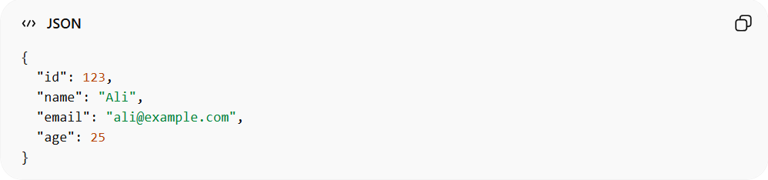
{
"id": 123,
"name": "Ali",
"email": "ali@example.com",
"age": 25
}
Here:
- /users/123 → Resource URL
- JSON object → Resource representation

Other Examples
# Source: AI Source: Provided by: [Data Path: Persons Table -> ID Column: 1, Name_En Column: Motasem Essam] -> From: [ChatGPT] on [1/19/2026]
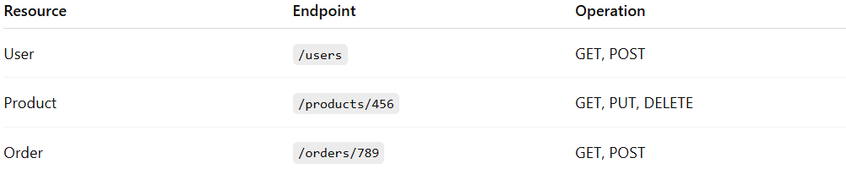
Resource | Endpoint | Operation
User | /users | GET, POST
Product | /products/456 | GET, PUT, DELETE
Order | /orders/789 | GET, POST

❌ Common Mistakes
# Source: AI Source: Provided by: [Data Path: Persons Table -> ID Column: 1, Name_En Column: Motasem Essam] -> From: [ChatGPT] on [1/19/2026]
- Treating API endpoints as procedures rather than resources
  - ❌ /getUserById?id=123
  - ✅ /users/123
- Mixing multiple resources in one endpoint
  - ❌ /getUserAndOrders?id=123
  - ✅ /users/123/orders

💡 Summary
# Source: AI Source: Provided by: [Data Path: Persons Table -> ID Column: 1, Name_En Column: Motasem Essam] -> From: [ChatGPT] on [1/19/2026]
An API Resource is a RESTful representation of an entity that clients can interact with through standard HTTP methods.

